SIGNING JAR FILES – HOW TO DOCUMENT
Notes:
Self-signing jar files to use for Oracle Forms have been a way to sign jar files without using a trusted vendor. Oracle has provided the sign_webutil.bat (or sign_webutil.sh) script to use for self-signing a jar file. As the self-signed certificates do not contain a trusted publisher name, any time a Forms application starts up, you may notice a Java security warning with a publisher “UNKNOWN”. This is because the self-signed certificate is not generated from a trusted vendor (VeriSign, Comodo, GoDaddy, etc.) and is not in the “Signer CA” list in the Java Control Panel on a user’s PC. This has been noticed more in recent months as users are unable to “always remember this option” when choosing to run an application with an UNKNOWN publisher starting with Java 7 Update 40 (or even getting an Application Blocked error when using JRE 7u51 or higher).
The best solution would be to sign your jar files with trusted code-signing certificates from a trusted vendor. However, you also have the option to add the self-signed certificate to your Java Control Panel to the list of Signer CA certificates which will add the self-signed certificate to the trusted list allowing you to run the application without the warning appearing (however, a Java notification will still appear with a publisher name that would be considered more trustworthy than “UNKNOWN”).
To configure this, you will need to update the sign_webutil script (used for self-signing jar files) in the platform running the Forms and Reports environment. After this, you will need to export a CSR certificate from the keystore which the script uses. The following steps will accomplish this:
STEP 1: SIGN_WEBUTIL.SH changes
1. Locate your sign_webutil.bat or sign_webutil.sh script. You can find it in %ORACLE_INSTANCE%\bin. Please make a backup of this file.
2. Open the file in a text editor.
3. Modify the following variables:
a. SET KEYSTORE_PASSWORD= Create a keystore password of your choice (CAUTION: The password will NOT be encrypted). For LifeTrak application: KEYSTORE_PASSWORD=mispasswd
b. SET JAR_KEY_PASSWORD= Create a private key password of your choice (CAUTION: The password will NOT be encrypted). For LifeTrak application: JAR_KEY_PASSWORD=mispasswd

4. Locate the line “SET DN_CN=Product Management”. This is the self-signed certificate information. If you want to use your own information, you may update the following four lines (below is an example). If you are fine with using the values Oracle has provided, you may skip to step 6. Below are the settings used for LifeTrak application
- DN_CN="MIS LifeTrak Certificate (2024)"
- DN_OU="Oracle Forms"
- DN_O="Mediware Information Systems"
- DN_C=US

5. Modify the below variable to give location of Keystore file.
KEYSTORE=$HOME/keystore/LT_identity.jks
6. Locate the line “JAR_KEY=weutil2”. This is the alias key. For LifeTrak application, it is set as JAR_KEY=LTselfsigned

7. Modify validdays variable and set it to 3600. VALIDDAYS=3600
8. Save and close the file
STEP 2: Add PERMISSIONS to JAR files
To update any custom-made jar files (or even jacob.jar) to include these parameters in the Java code, you may follow these steps:
- Navigate to %ORACLE_HOME%\forms\java ($ORACLE_HOME/forms/java).
- Create a new file called LTmanifest.txt using a text editor.
- Add the following values into the text file:
  - Permissions: all-permissions
  - codebase: *
  - Application-Name: OracleForms

- IMPORTANT: Please add a line below the Application-Name attribute. Otherwise, this attribute will not be added to the manifest file!
- Save and close the file.
- Make sure that PATH variable is set with JDK
export PATH=/apps/Middleware/jdk1.6.0_45:$PATH
- Run the below command for all the custom jar files.
  - jar –ufm jacob.jar LTmanifest.txt
  - jar –ufm donor.jar LTmanifest.txt
  - jar –ufm hyperlink.jar LTmanifest.txt
  - jar –ufm laf.jar LTmanifest.txt
- Sign the jar files, deploy and restart WLS_FORMS.
If successful, you should no longer see the “Missing permissions manifest…” and “Missing codebase manifest…” errors for your custom-made jar files.

STEP 3: SIGN JAR FILES
- Make sure that sign_webutil.sh has appropriate values set for LifeTrak application (Above Section).
- If you attempt to re-sign a JAR file that is already signed, it will contain multiple signature in the “META-INF” directory, which may probably result in the below error:
sun.security.validator.ValidatorException: PKIX path validation failed:
java.security.cert.CertPathValidatorException: signature check failed
To fix this, unpack the JAR, remove the signatures from the META-INF directory and re-pack the JAR. Use the script “resign_jars.sh” to accomplish this. Set the environment variables and the custom jar files in the script as shown below:
#!/bin/sh
export MW_HOME=/apps/Middleware
export WLS_HOME=$MW_HOME/wlserver_10.3
export WL_HOME=$WLS_HOME
export ORACLE_HOME=$MW_HOME/Oracle_FRHome1
export ORACLE_INSTANCE=$MW_HOME/LT_Inst
export FR_HOME=$ORACLE_HOME
export FR_INST=$ORACLE_INSTANCE
export DOMAIN_HOME=$MW_HOME/user_projects/domains/ClassicDomain
export JAVA_HOME=$MW_HOME/jdk1.6.0_45

mkdir $FR_HOME/forms/java/temp
cd $FR_HOME/forms/java/temp

function sign_jar {
export MYJAR=$1
unzip ../$MYJAR
rm -f META-INF/*.SF META-INF/*.DSA META-INF/*.MF
# You may need to remove more, so visually check.
$JAVA_HOME/bin/jar -cvf $MYJAR *
mv $MYJAR ..
rm -Rf *
$FR_INST/bin/sign_webutil.sh $FR_HOME/forms/java/$MYJAR
}

# Add any custom JARs into the list.
sign_jar donor.jar
sign_jar hyperlink.jar
sign_jar jacob.jar
sign_jar laf.jar

cd ..
rmdir $FR_HOME/forms/java/temp

STEP 4: DEPLOY
1. Deploy the signed jar files in %ORACLE_HOME%\forms\java
2. Restart WLS_FORMS if it is running

STEP 5: CERITIFICATE EXPORT
- Go to the location of your keystore file that is specified in the sign_webutil script inside Command Prompt or your SSH terminal.
- Ensure that the JDK is in the PATH environment variable
export PATH=/apps/Middleware/jdk1.6.0_45:$PATH
- Run the following command to extract a CSR from the keystore. Keystore value, alias value are taken from the values set in sign_webutil.sh. Certificate name is given as LT2013.csr
keytool -export -keystore LT_identity.jks -alias LTselfsigned –file LifeTrak.csr
- Please keep the CSR file handy. This file will need to be sent to any end user who plans to use the application.
STEP 6: CERTIFICATE IMPORT on End User’s PC ONLY
- In the end-user’s PC, open up the Java Control Panel from Control Panel. This can be done by clicking on Control Panel from the Start button. Once there, expand the Control Panel and select “All Control Panel Items”. Double-click on Java.
- Go to the Security tab and click “Manage Certificates…”.
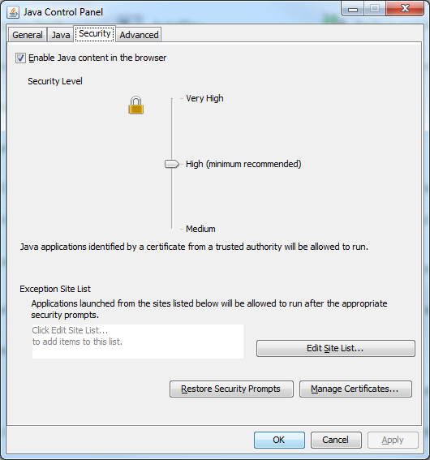

- Specify “Signer CA” as the Certificate type. Click “Import” to import the CSR.
- Once it is imported, it will be in your list of trusted certificates for that PC.
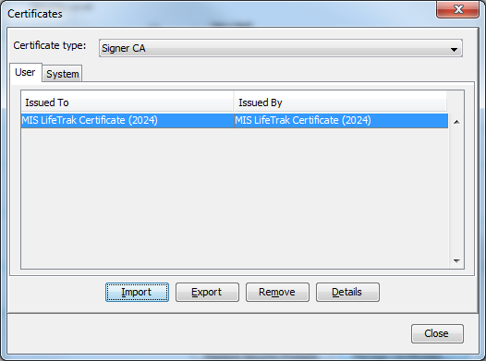
- After applying the steps above, you should see a more trustworthy Java notification similar to the one below instead of a security warning which will allow you to remember the option to run the application (even when using the latest JRE):

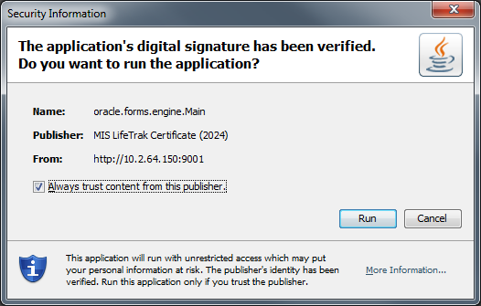

Final Notes:

All the above steps are a onetime process and must be performed in DEV environment only. Once the jar files are signed, we can just copy the signed jar files to other environments – QA/PROD. We do not have to copy keystore or any other script files that were modified in this document to other environments.

If there are any changes to custom JAR files like adding a new image, you just need to resign the CUSTOM jar files using RESIGN_JARS.sh

DO NOT SIGN ANY ORACLE SUPPLIED - FRM JAR FILES.

Sources:
- http://pitss.com/us/2013/10/24/how-to-modify-custom-jar-files-with-permissions-and-codebase-attributes/
- http://pitss.com/us/2014/05/15/how-to-add-self-signed-certificates-to-the-list-of-trusted-certificates-in-the-java-runtime/
- http://oracle-base.com/articles/11g/oracle-forms-and-reports-11gr2-configuration-notes.php
- Oracle Metalink notes: 1596871.1, 1583119.1, 1076945.1

